Code coverage details tested by Sonarlint 60.4%

StatementProcessControllerTest.java in Junit4

By right clicking in body , covered as Junit Test yields the percentage of coverage

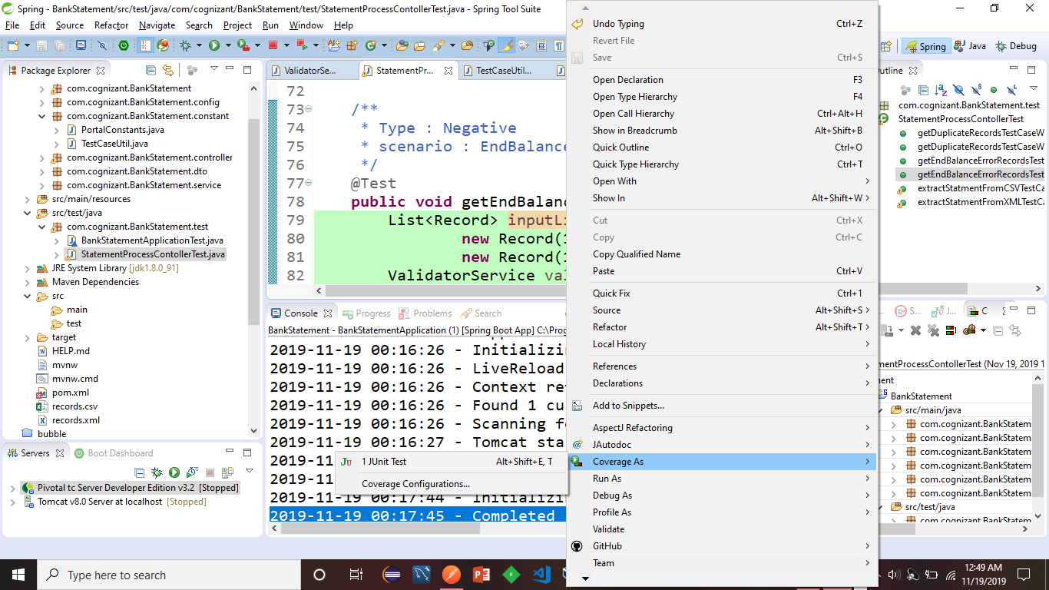

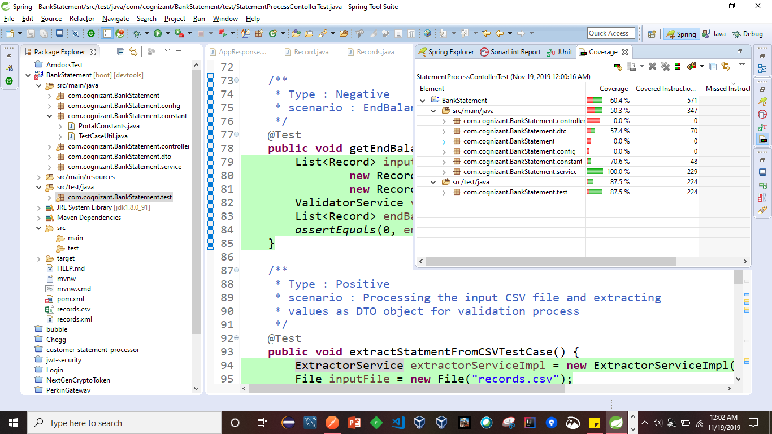

After importing the project right click and do maven build

Clean install

PFB

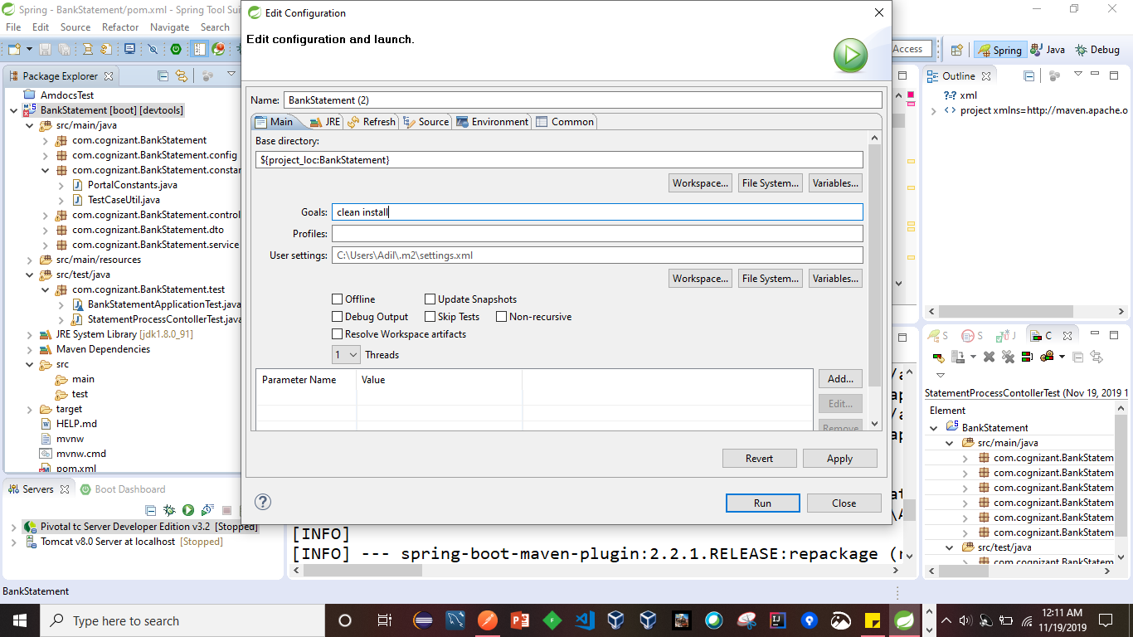

After build success

Run as Spring Boot app

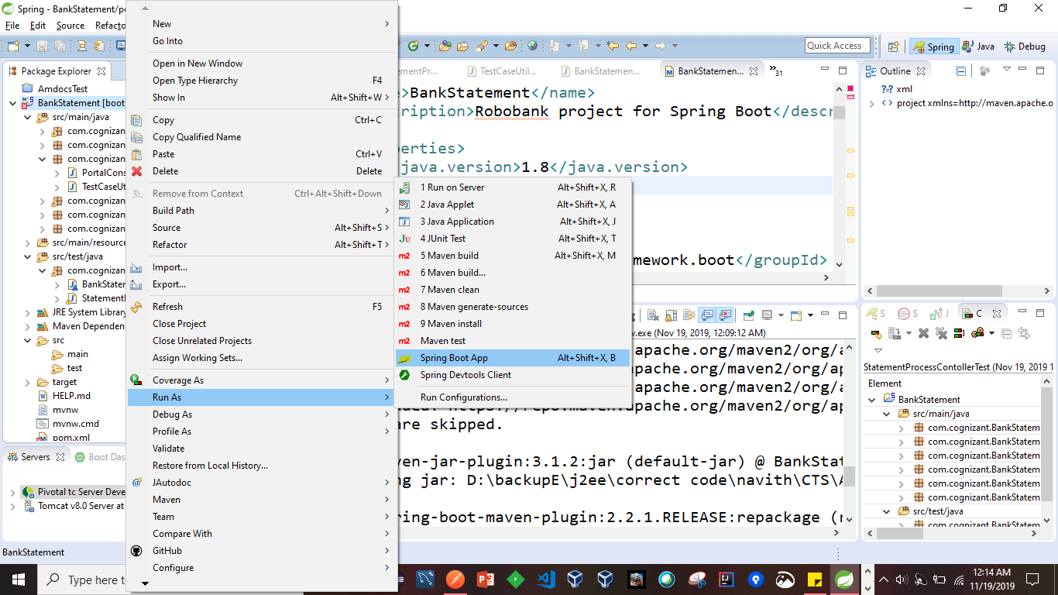

Then project started on 8181 port

Actuator health is up

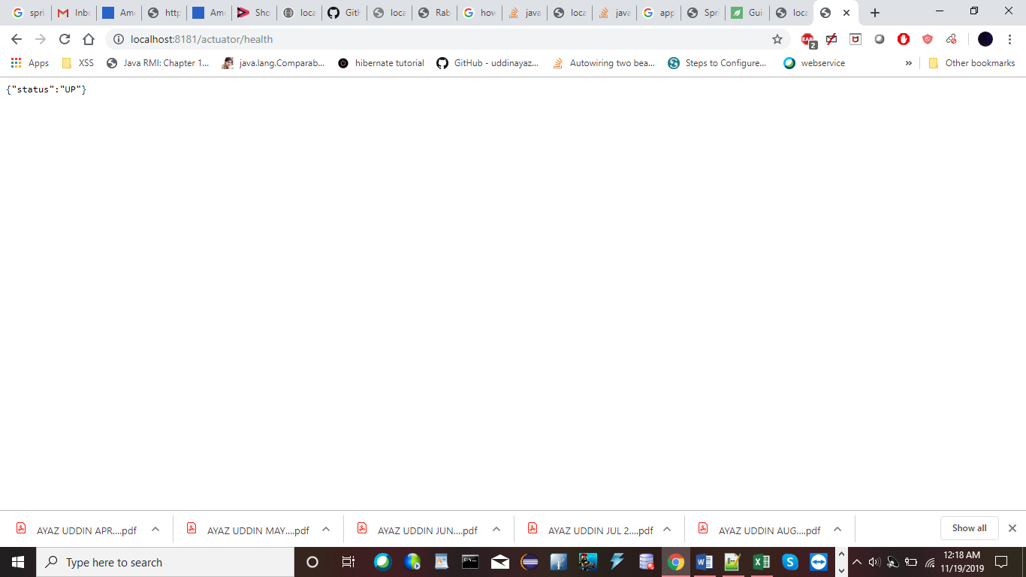

Swagger link is <http://localhost:8181/swagger-ui.html>

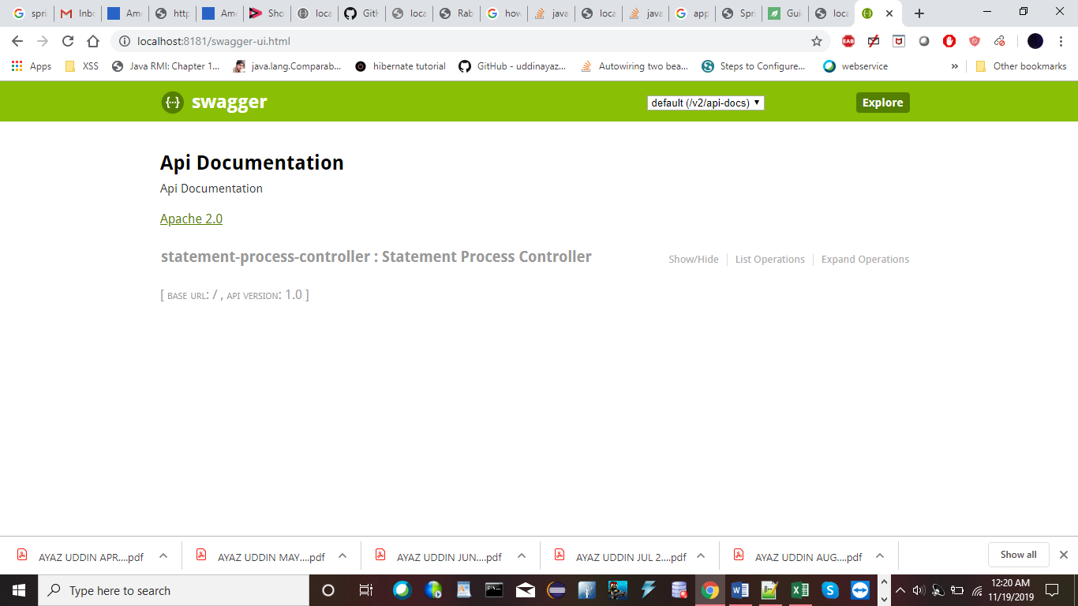

On clicking list of operation, displays all possible methods

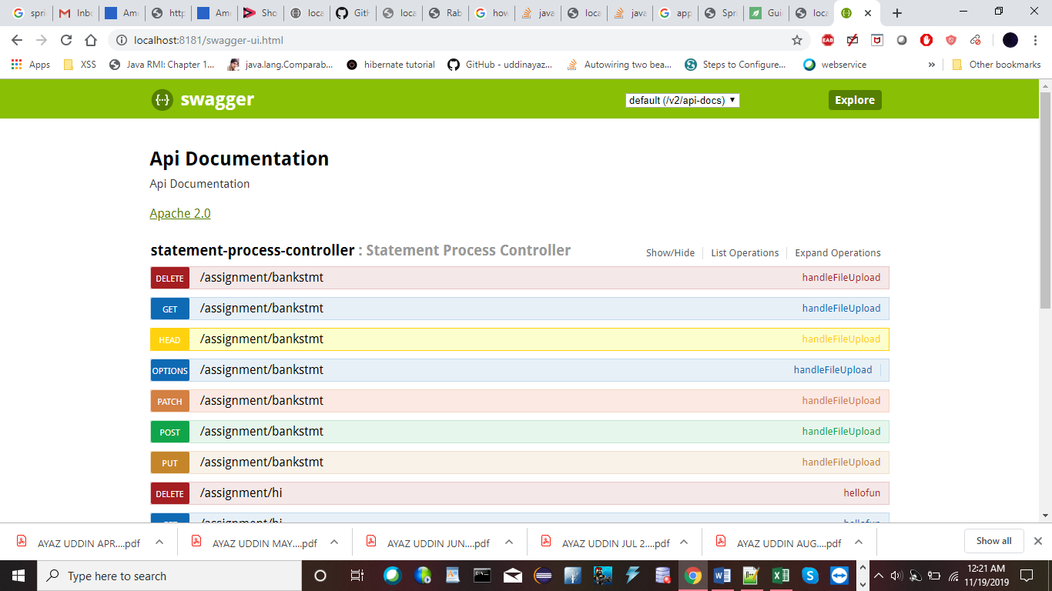 In Postman tool it is better to try out these operations

For uploading CSV or XML we need to type <http://localhost:8181/assignment/bankstmt> in uri section

post method, body, form-data , file where in choose one browse the csv file in project

then send the request to see output

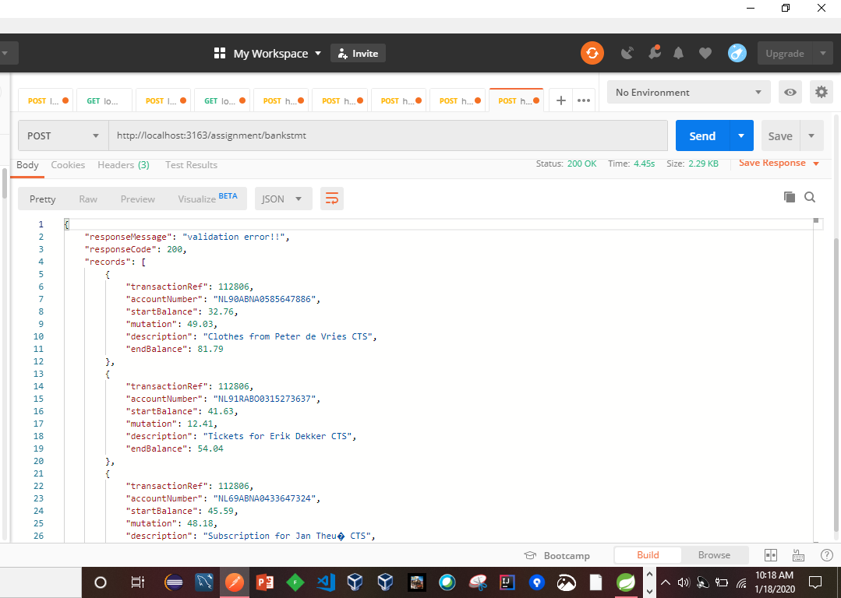

transaction ref is unique

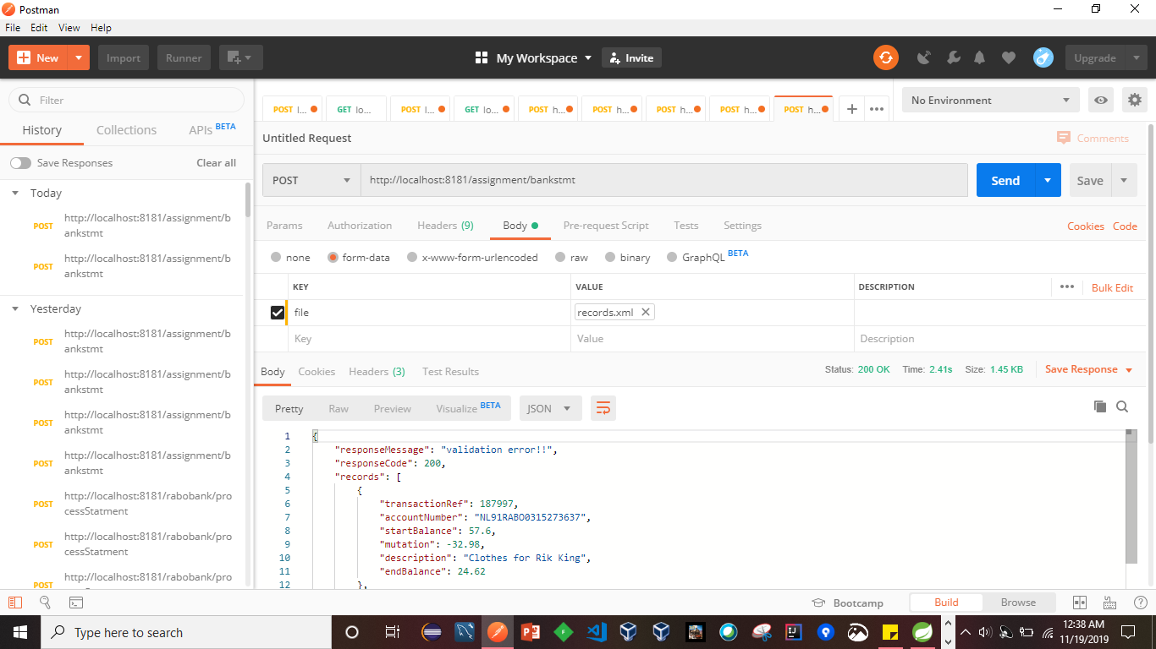

CSV and XML is allowed

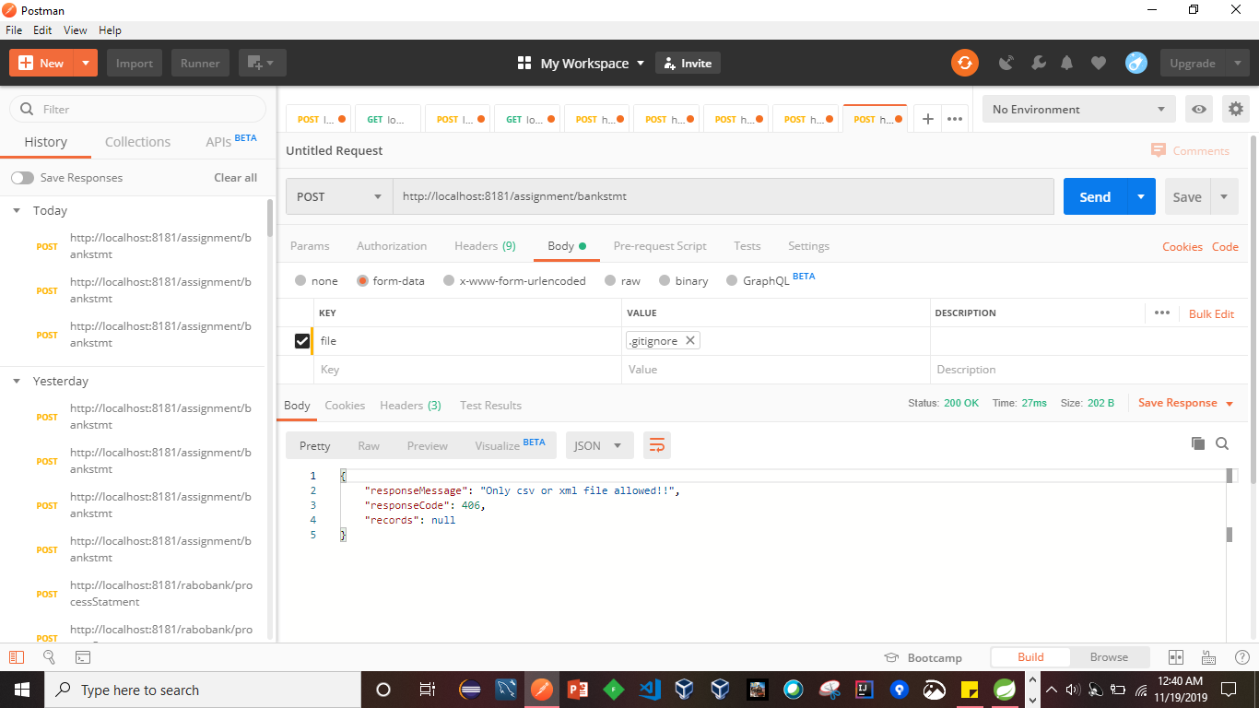

Cosole log configured in application.properties

After hilighted line all are log in cosole

